ResNet18 Testing

Original:

* 15 epochs in 23 minutes

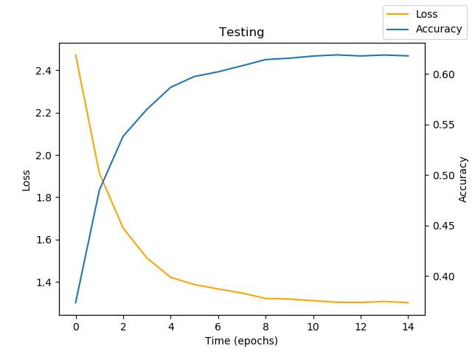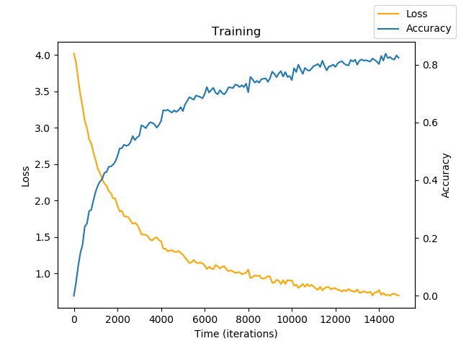

02/04/20:

* 30 epochs
* Sigmoided output
* LR decay every 5000 iterations

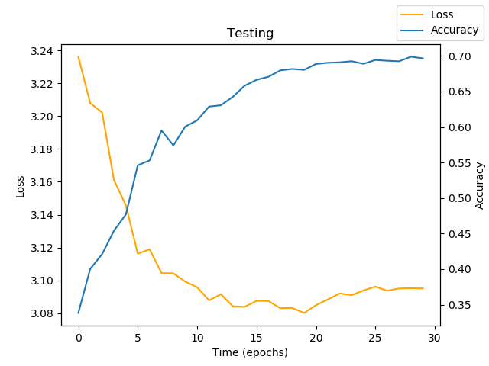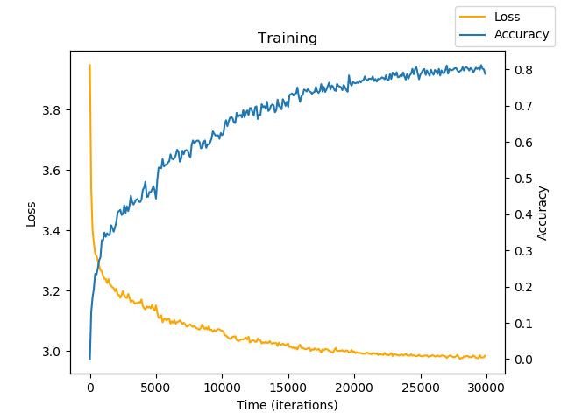

02/05/20:

* 60 epochs
* Not sigmoided
* LR decay every 5000 iterations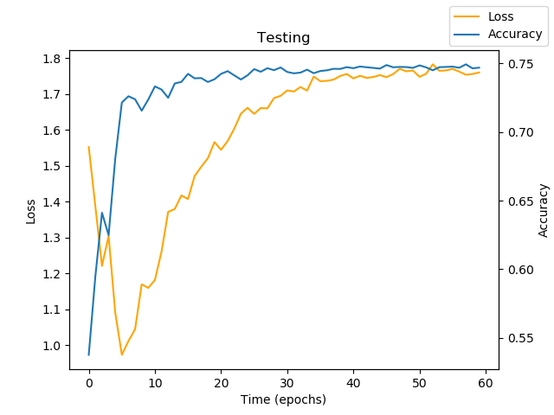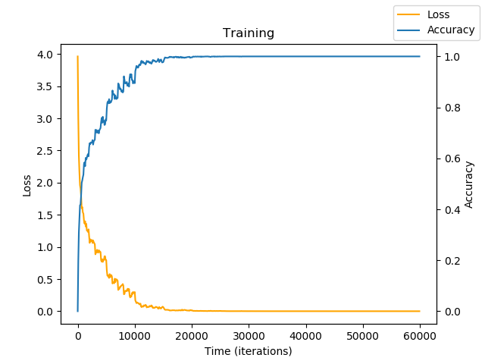

02/05/20:

* 60 epochs
* Sigmoided
* LR decay every 5000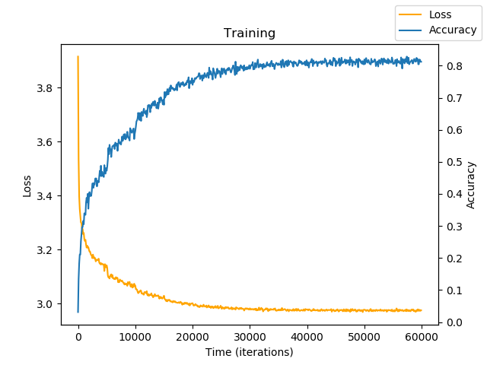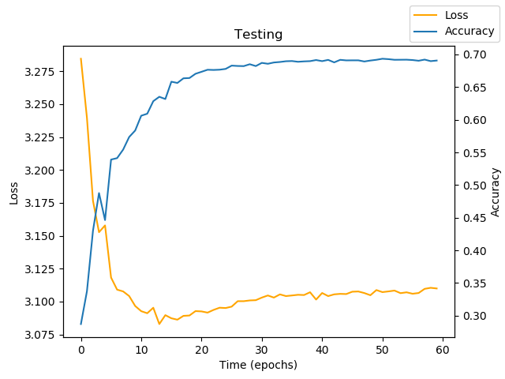

02/11/20:

* 60 Epochs
* Non-sigmoided
* LR decay every by .5 every 5000
* Smoothed with blur across joints (3,1) kernel
* Values between -.5 and .5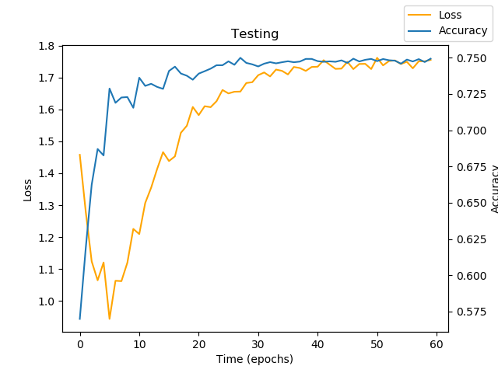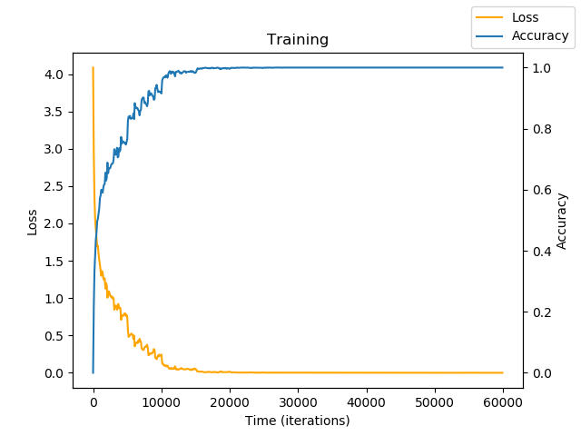

02/12/20:

* 60 Epochs
* sigmoided
* LR decay every by .5 every 5000
* Smoothed with blur across joints (3,1) kernel
* Values between -.5 and .5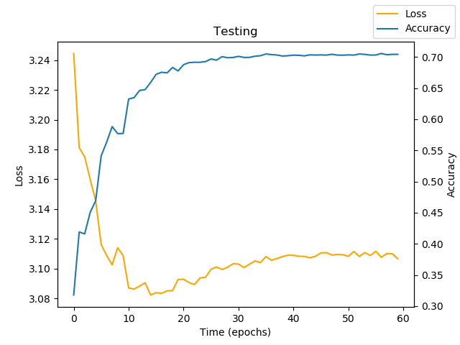

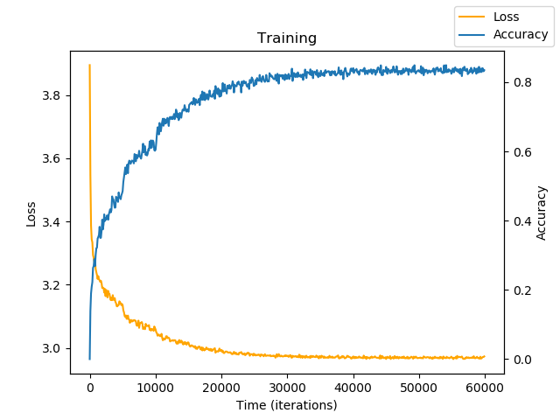

02/13/20:

* 30 Epochs
* Non sigmoided
* LR decay by .5 every 5000 iterations
* Smoothed with blur across joints (5,1) kernel
* Values between -.5 and .5

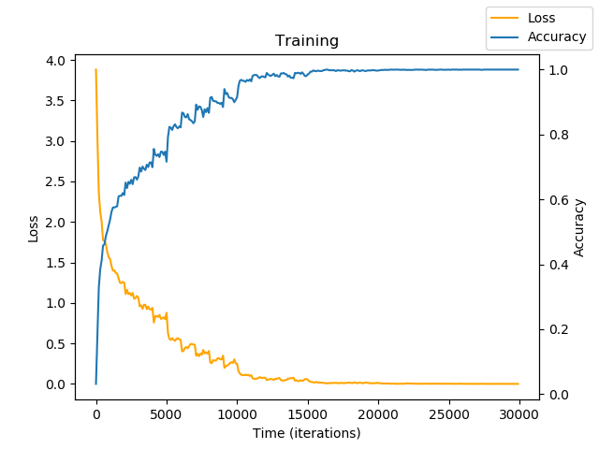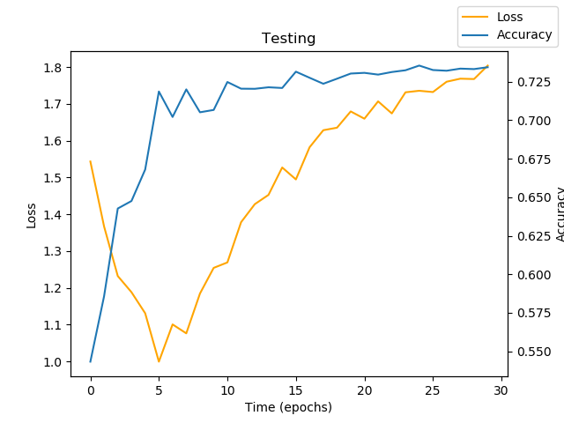

02/13/20:

* 30 Epochs
* Non sigmoided
* LR decay by .5 every 5000 iterations
* Smoothed with gaussian blur across joints (3,1) kernel
* Values between -.5 and .5

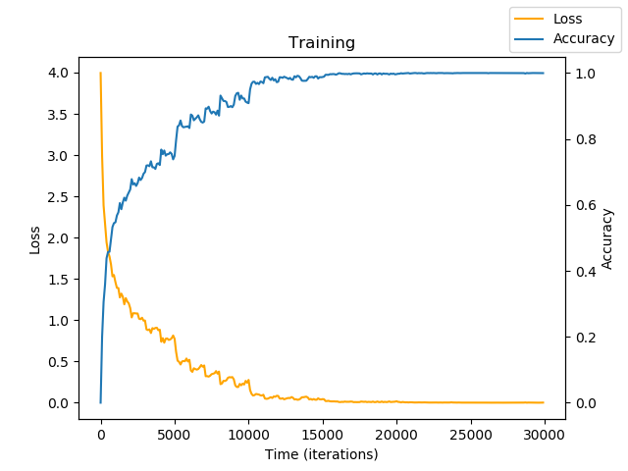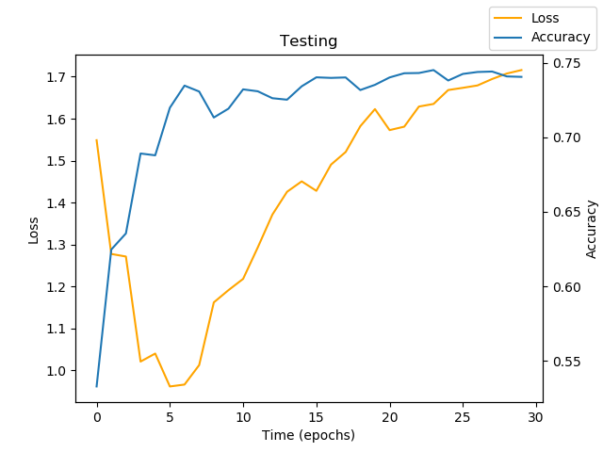

02/13/20:

* 30 Epochs
* Non sigmoided
* LR decay by .5 every 5000 iterations
* Smoothed with gaussian blur across joints (5,1) kernel
* Values between -.5 and .5

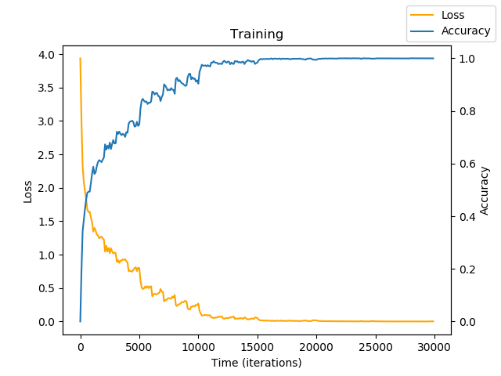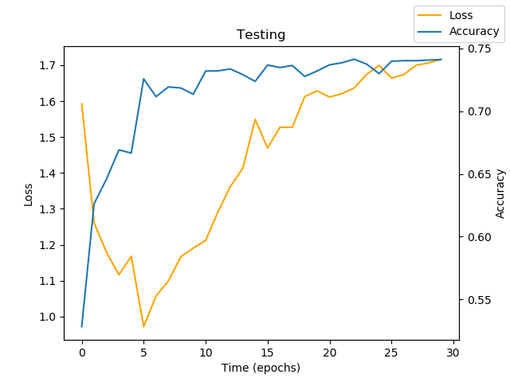

02/19/20:

* Resnet 150
* 30 Epochs
* Non sigmoided
* LR decay by .5 every 5000 iterations
* Smoothed with gaussian blur across joints (5,1) kernel
* Values between -.5 and .5

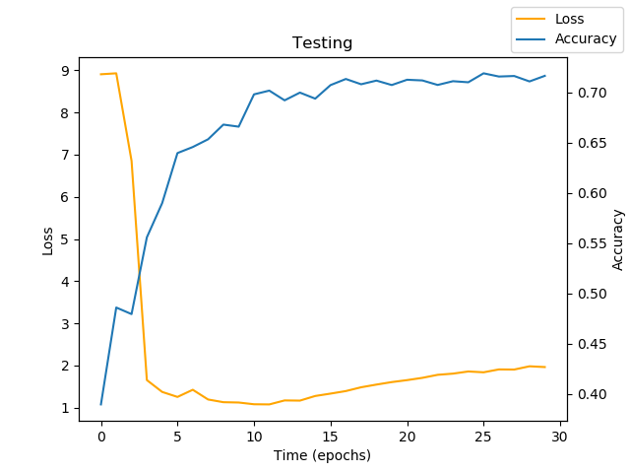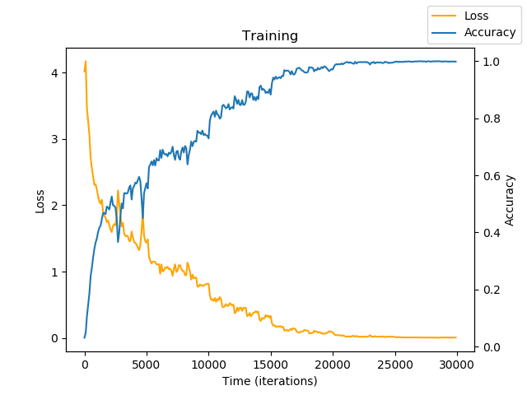

02/20/20:

* 30 Epochs
* Non-sigmoided
* LR decay .5 every 5000 iterations
* Smoothed with bilateral filter (9,150,150)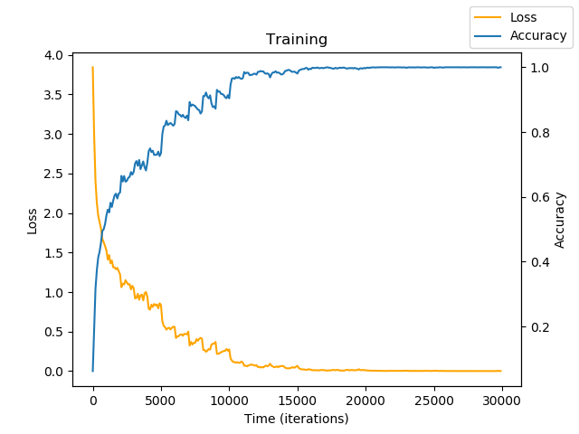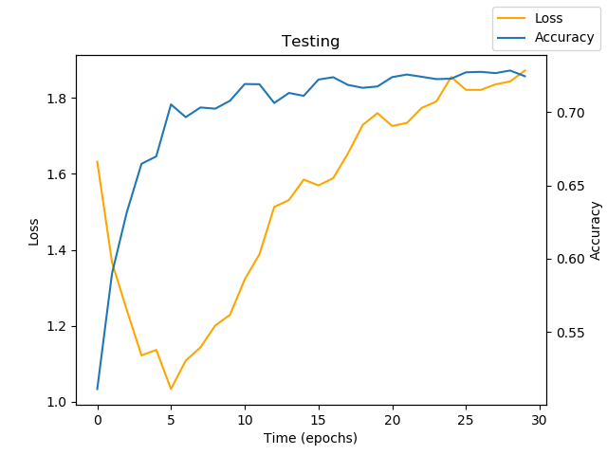
* Values between -.5 and .5
* 30 Epochs
* Non-sigmoided
* LR decay .5 every 5000 iterations
* Smoothed with bilateral filter (9,150,150)
* Values between -.5 and .5
* Joint grouping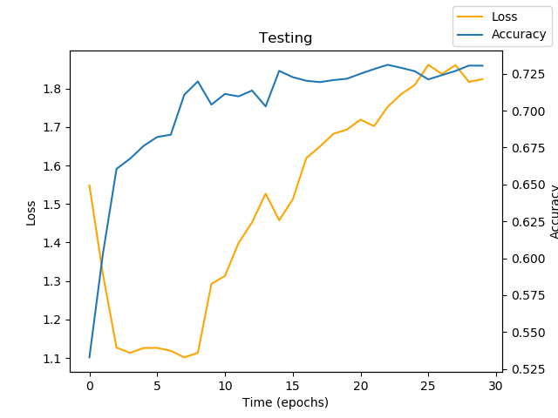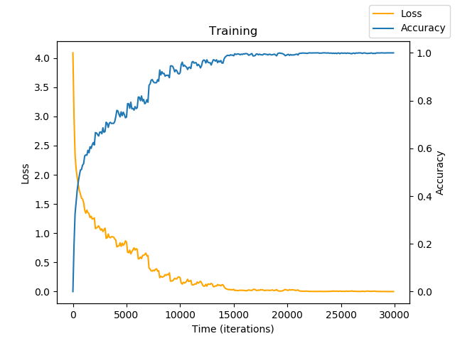
* 30 Epochs
* Non-sigmoided
* LR decay .5 every 5000 iterations
* Smoothed with bilateral filter: (6, 50, 200)
* Values between -.5 and .5
* Joint grouping
* Filters: 3 -> 32 -> 64 …

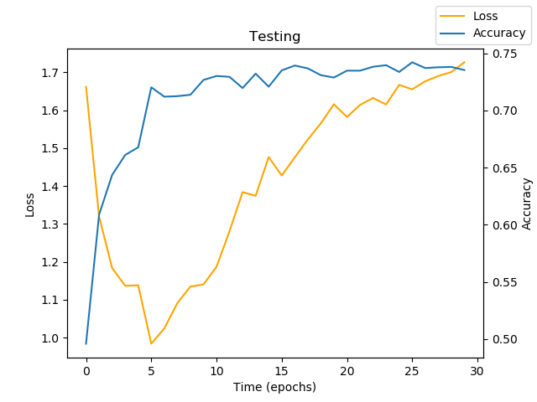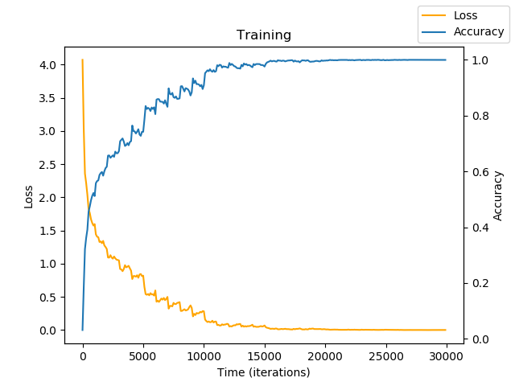

* 30 Epochs
* Non-sigmoided
* LR decay .5 every 7000 iterations
* Smoothed with bilateral filter (6,50,200)
* Values between -.5 and .5
* Joint Grouping
* Filters 3 -> 64 -> 128 …

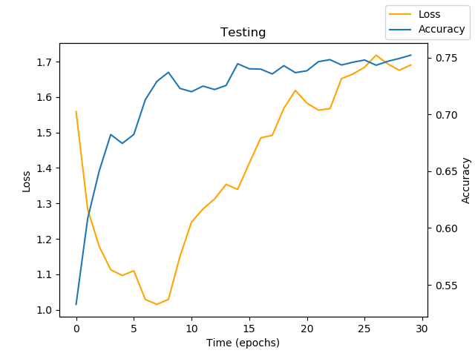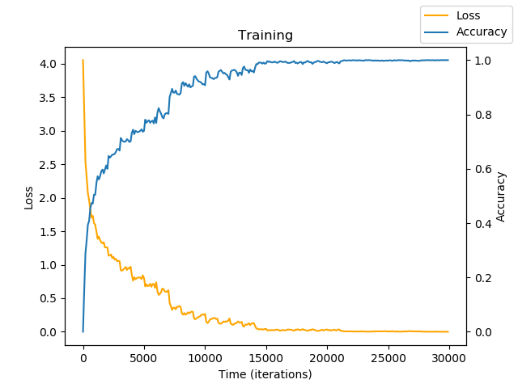

* 30 Epochs
* Non-sigmoided
* LR decay .5 every 7000 iterations
* Smoothed with bilateral filter (6,50,200)
* Values between -.5 and .5
* Joint Grouping (improved)
* Filters 3 -> 128 -> 512 …